# Goal

* First learn Unity and freelancing unity 2d gig in fiverr/ upwork / other marketplace
* 3d gig and make a gig in that particular marketplace
* Make a gig using unreal engine related
* Start learning graphics programming and get a job in tencent or other gaming industry as a graphics programmer or game developer

# 2D GAME DEVELOPMENT FULL NOTE

**April 6, 2025**

# Introduction setup

Essential note:

1. In introduction to unity there I have made a pretend platformer using “Sprites all elements”

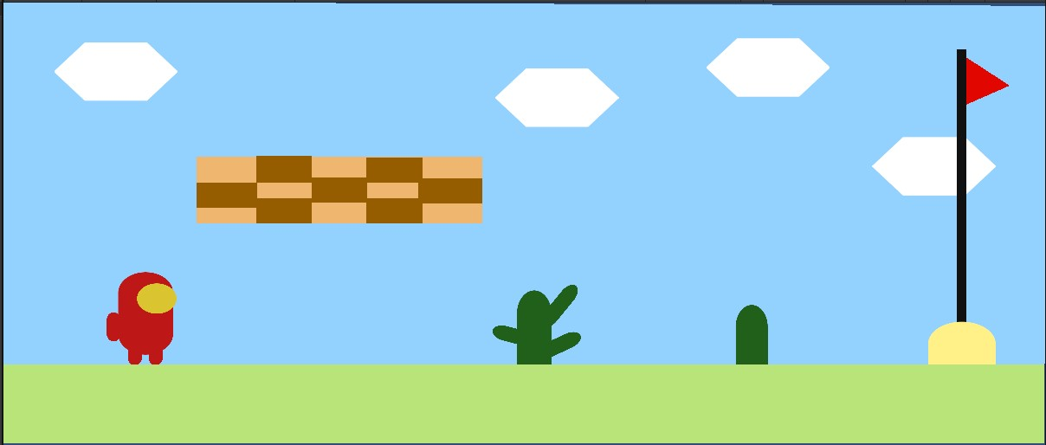

Added it in Gamedev.tv website:

<https://community.gamedev.tv/t/show-your-pretend-platformer-screenshot/168220?u=md_rakib>

1. Setup VS code: install vs code and check which compiler is active

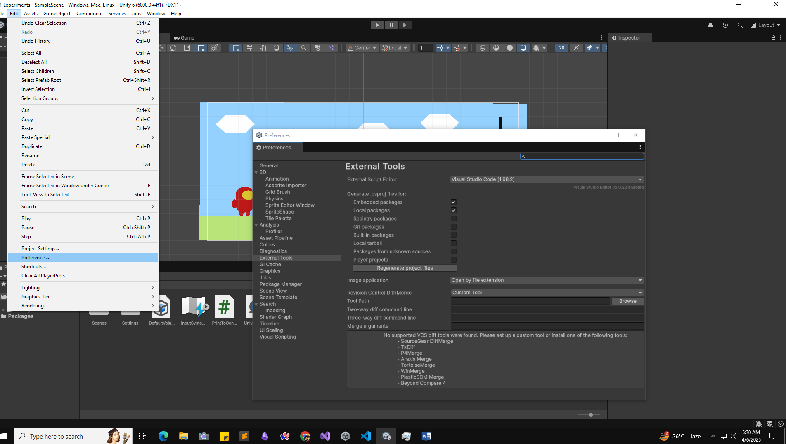

Just check and then add a empty script of C# and double click in file it will open in vscode.

Ensure 2 extension is important:

1. C# by Microsoft and

2. Unity Code Snippets by Kleber Silva

Update code in vs code:

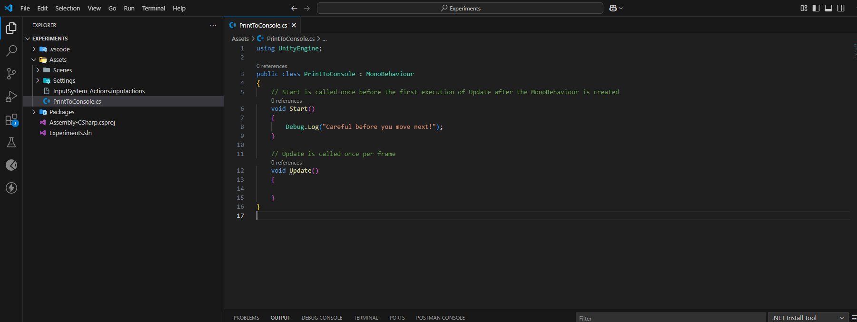

**Community support:**

* Community.Gamedev.tv
* GameDev.tv discord

# Delivery Driver

Complete the Fundamental concepts of c# such as:

* Variables
* If statements
* Methods
* Triggers
* Colliders
* References (getting components and accessing those properties)

Game Design:

Make a rough mockup if possible where just mark down all the elements:

# 

Now just think about what we have to program or what we have to make:

# 

3 main things:

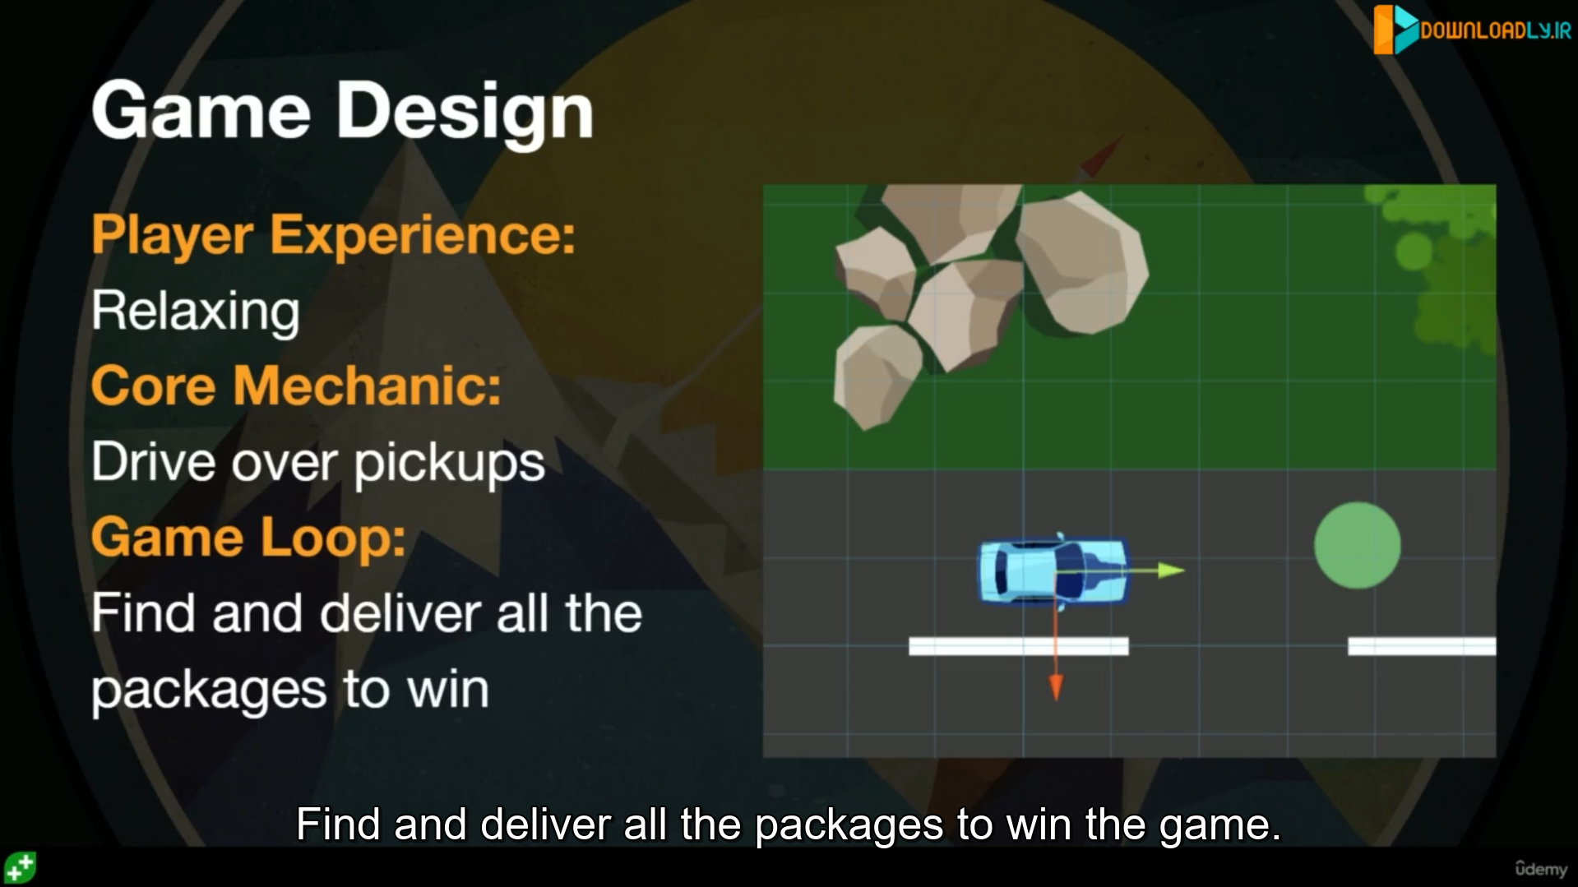

Introducing Method:

Capsule spinning using rotate method

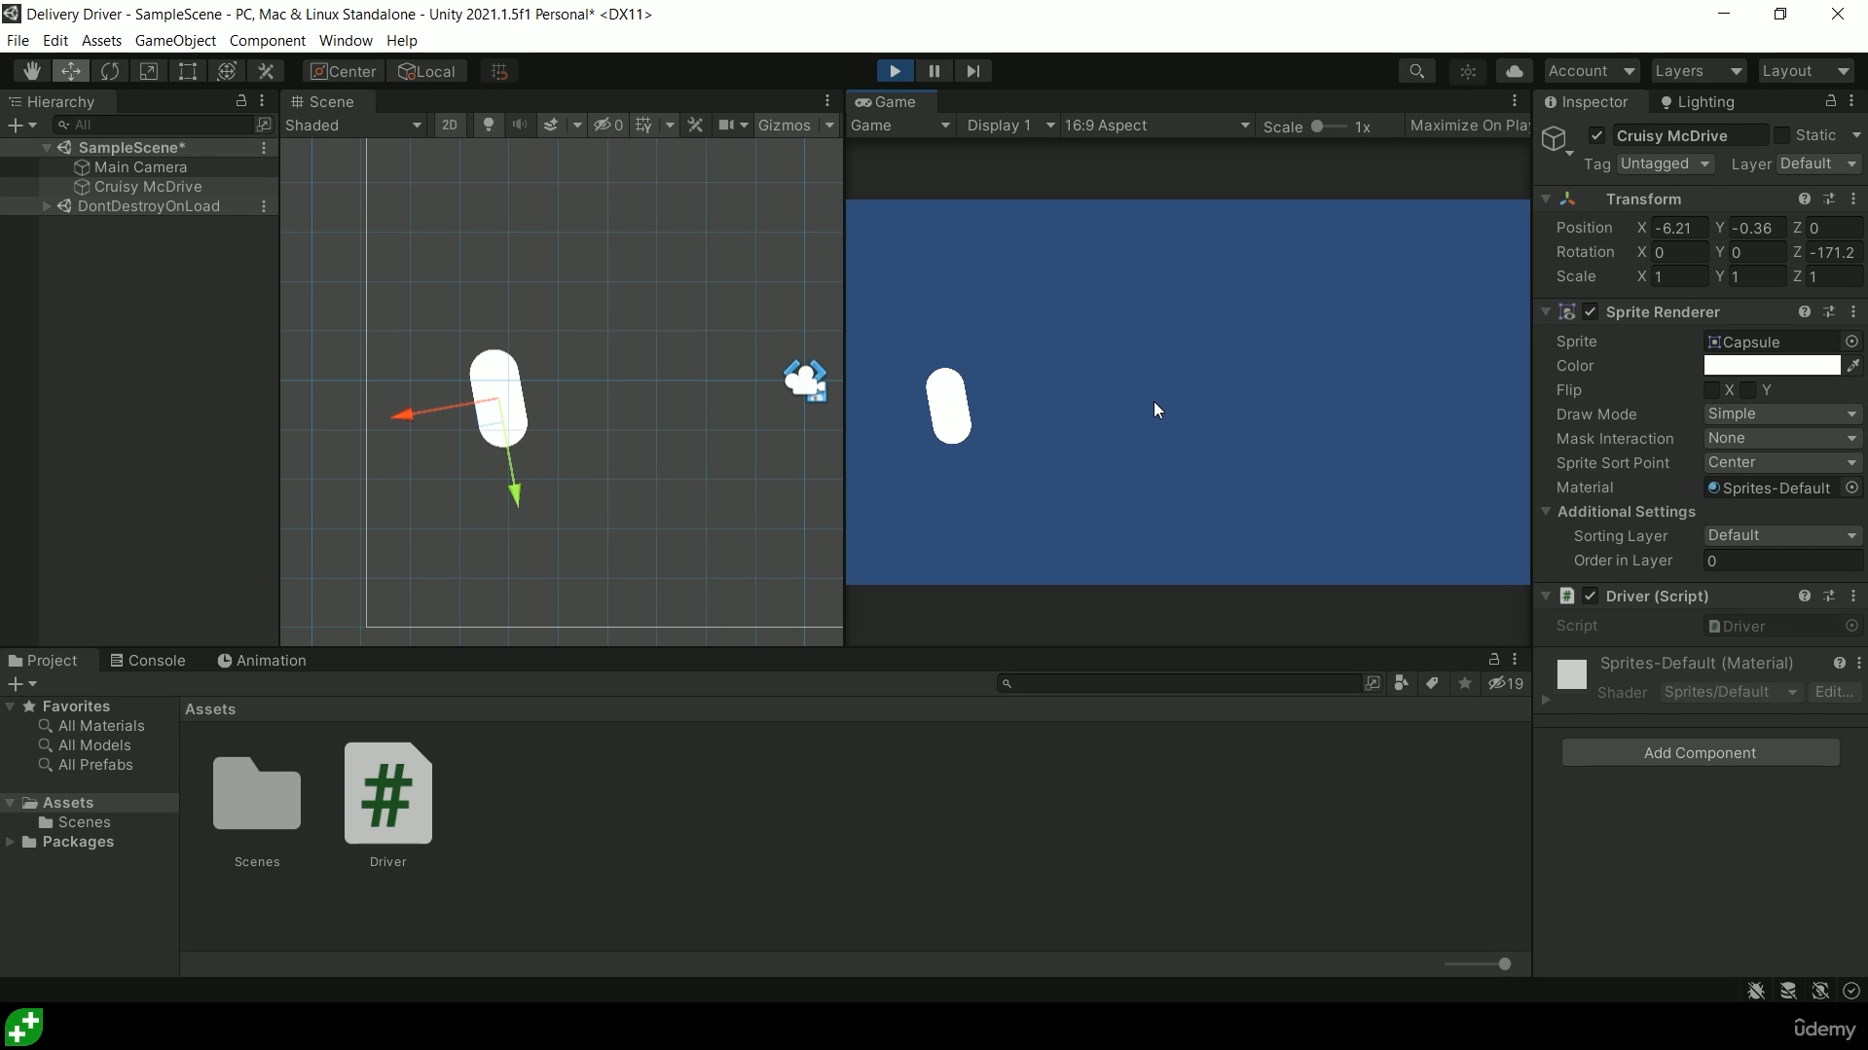

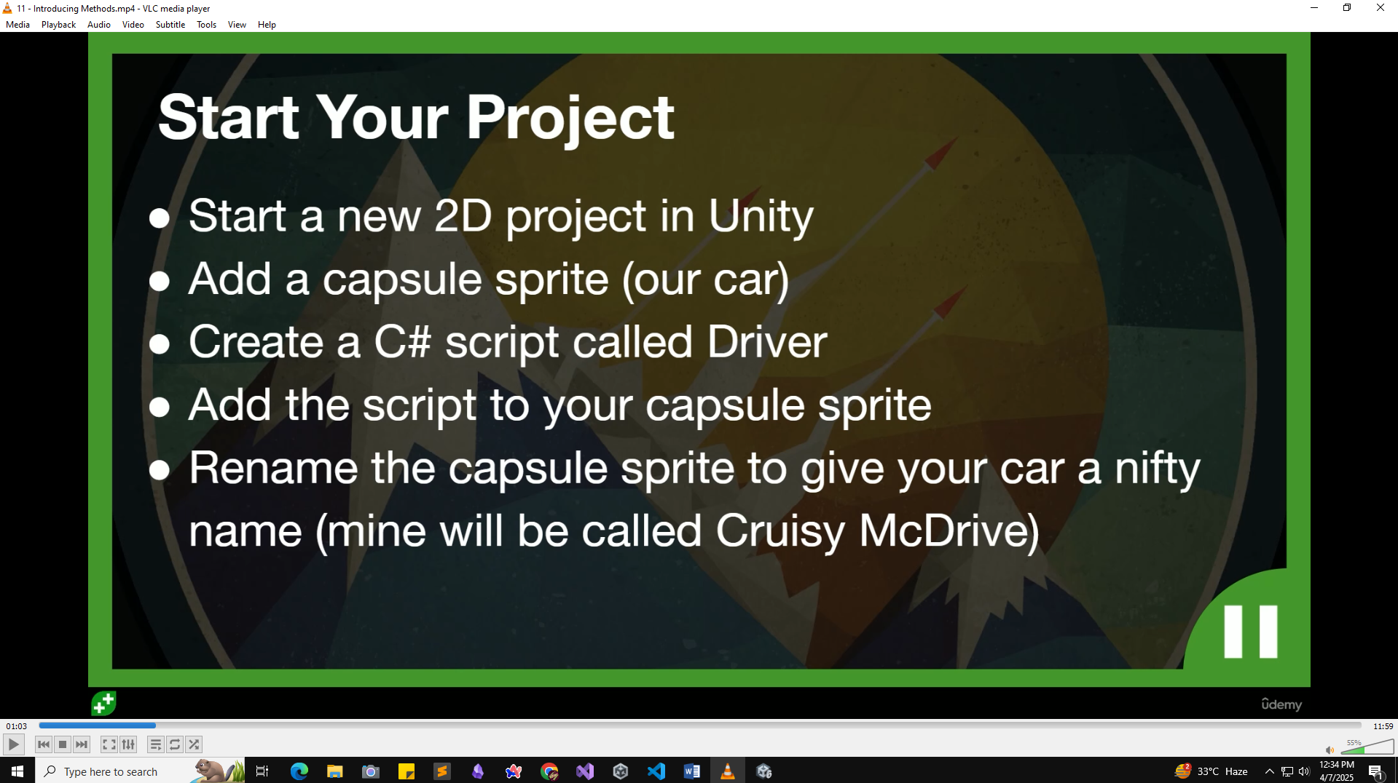

Successfully moved the capsule by modifying driver scripts.

using UnityEngine;

public class Driver : MonoBehaviour

{

    // Start is called once before the first execution of Update after the MonoBehaviour is created

    void Start()

    {

    }

    // Update is called once per frame

    void Update()

    {

        transform.Rotate(0, 0, 0.2f);

    }

}

Transform.Translate:

using UnityEngine;

public class Driver : MonoBehaviour

{

    // Start is called once before the first execution of Update after the MonoBehaviour is created

    void Start()

    {

    }

    // Update is called once per frame

    void Update()

    {

        transform.Rotate(0, 0, 0.1f);

        transform.Translate(0, 0.01f, 0);

    }

}

Its now rotating automatically for using both method:

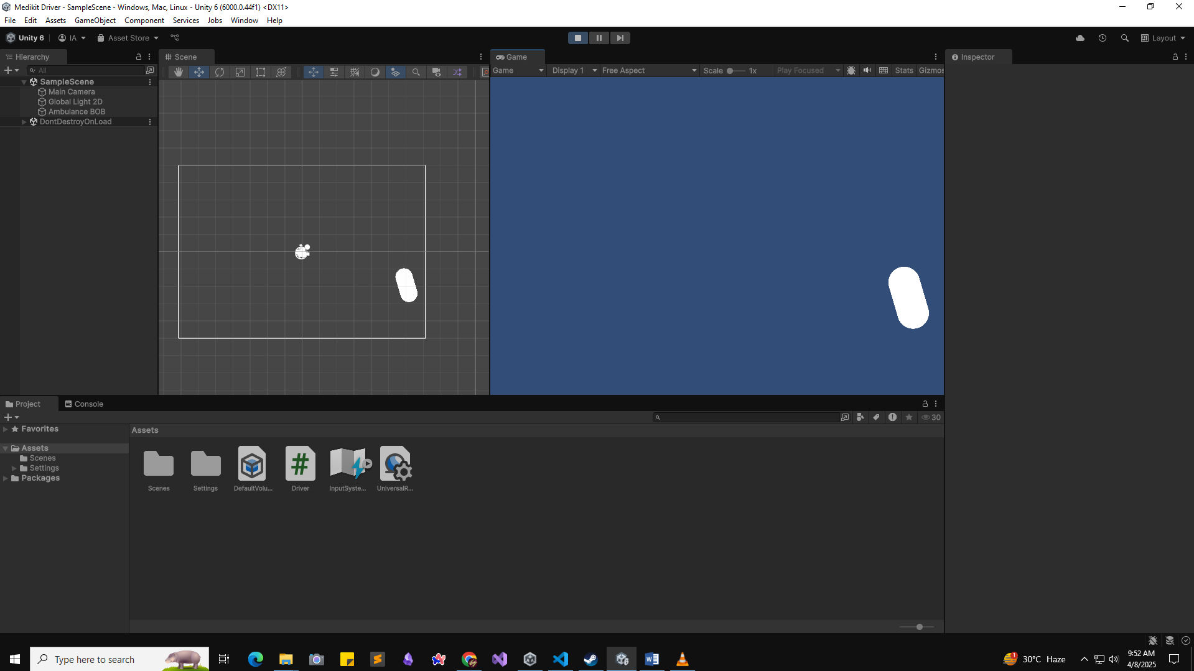

Introducing Variables:

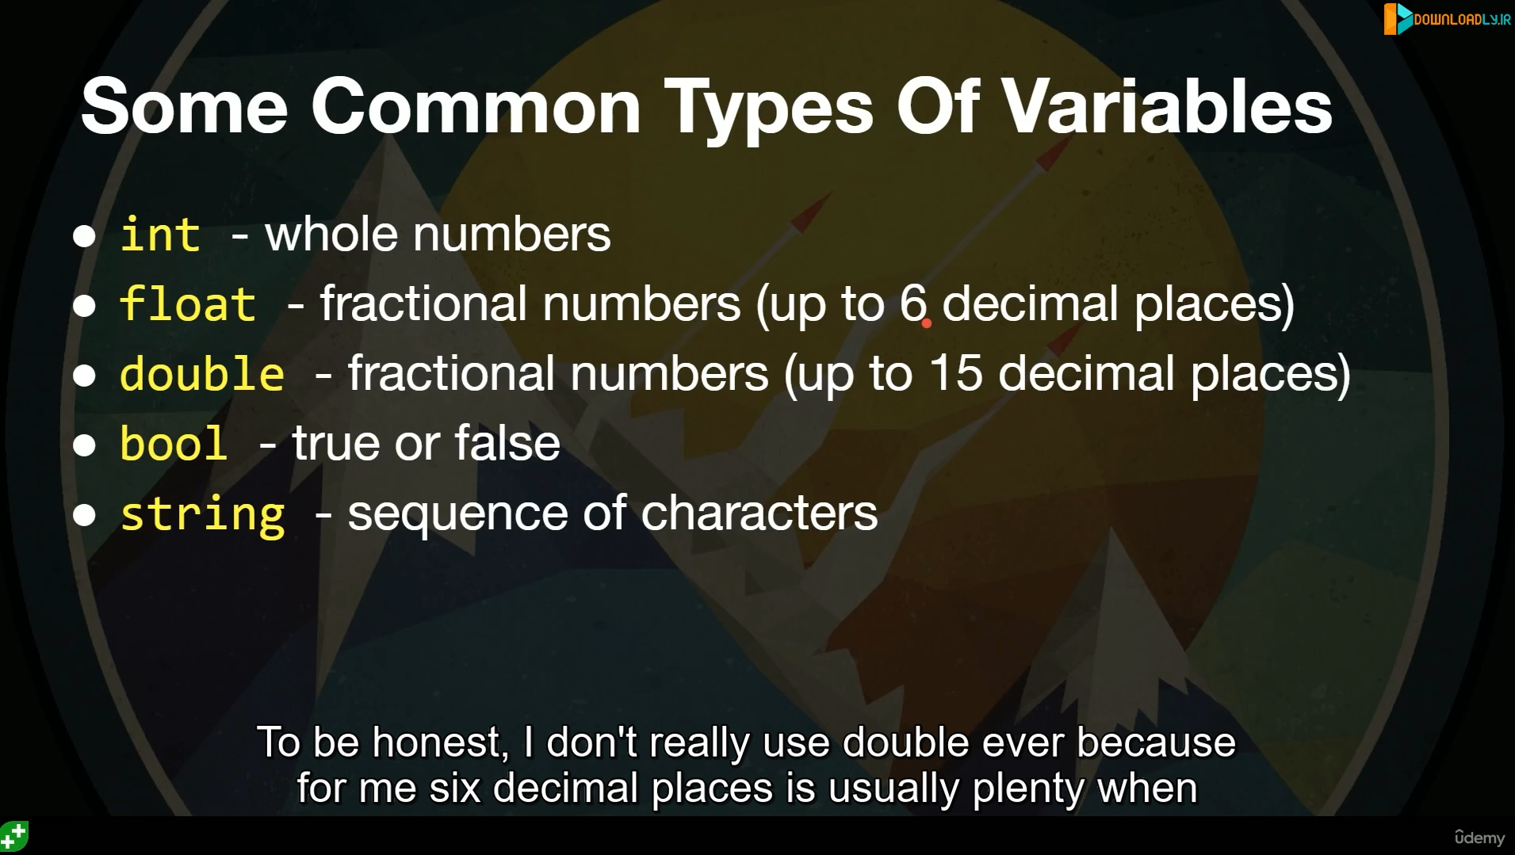

float steerSpeed = 1f;

SerializeField:

using UnityEngine;

public class Driver : MonoBehaviour

{

    float steerSpeed = 1f;

    [SerializeField] float moveSpeed = 0.01f;

    // Start is called once before the first execution of Update after the MonoBehaviour is created

    void Start()

    {

    }

    // Update is called once per frame

    void Update()

    {

        transform.Rotate(0, 0, steerSpeed);

        transform.Translate(0, moveSpeed, 0);

    }

}

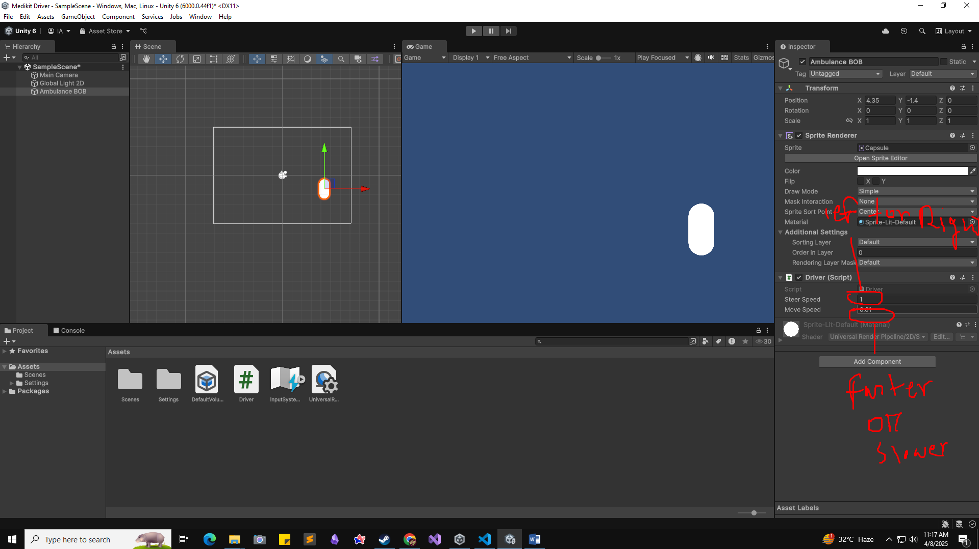

Using inputGetAxis:

Control our car using keyboard arrow keys.

using UnityEngine;

public class Driver : MonoBehaviour

{

    [SerializeField] float steerSpeed = 1f;

    [SerializeField] float moveSpeed = 0.01f;

    // Start is called once before the first execution of Update after the MonoBehaviour is created

    void Start()

    {

    }

    // Update is called once per frame

    void Update()

    {

        float steerAmount = Input.GetAxis("Horizontal") * steerSpeed;

        float moveAmount = Input.GetAxis("Vertical") * moveSpeed;

        // transform.Rotate(0, 0, steerSpeed);

        transform.Rotate(0, 0, -steerAmount);

        // transform.Translate(0, moveSpeed, 0);

        transform.Translate(0, moveAmount, 0);

    }

}

Now can control our car with our arrow keys.